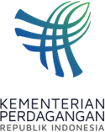
PRESS RELEASE
Public Relations Bureau
Bldg. I Fl. 2, Jl. M.I. Ridwan Rais No. 5, Jakarta 10110 Phone: 021-3860371/Fax: 021-3508711
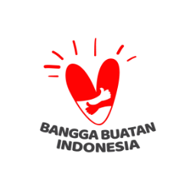
www.kemendag.go.id

The 3rd AEM-UK Consultation Meeting, Minister of Trade Zulkifli Hasan: Discuss the Development of Economic Cooperation
Semarang, 20 August 2023 – The ASEAN Economic Ministers (AEM) again held a consultative meeting with a partner country. Led by Minister of Trade Zulkifli Hasan, AEM held the 3rd AEM-UK Consultation Meeting in Semarang, Central Java on Sunday (20/8). At the meeting, the British delegation was led by British Minister of State for International Trade Nigel Huddleston MP. This meeting is part of the series of the 55th AEM Meeting and related meetings being held on 17-22 August 2023.

"Today's 8th meeting is the 3rd Consultation of ASEAN Economic Ministers with the UK. The meeting discussed several issues, namely the development of ASEAN-UK economic cooperation 2022-2023, the ASEAN-UK economic integration program 2024-2025, as well as efforts to encourage inclusive and resilient growth throughout ASEAN. Meanwhile the economic integration program covers three areas, namely, regulatory reform, trade that is more free from barriers, and financial services," explained Trade Minister Zulkifli Hasan.

In his remarks, the Minister of Trade Zulkifli Hasan said that this meeting was an important momentum to strengthen the economy between ASEAN and the UK.

"I hope we can collaborate, prioritize the spirit of togetherness, and provide clear directions through discussions of real and concrete solutions to drive several initiatives and cooperation that can support economic growth in the two regions," said Trade Minister Zulkifli Hasan.

Trade Minister Zulkifli Hasan appreciated the UK's willingness to attend the AEM-UK Consultation Meeting. "I express my utmost appreciation for your willingness to attend in person. It is an honor for me, as Chair of the ASEAN Economic Ministers this year, to be able to lead the course of the meeting," he added.

The meeting closed with dialogue between the ASEAN Business Council and the UK (UK-ASEAN Business Council/UKABC). This dialogue discussed UKABC's cooperation and recommendations for 2023, including green finance, digital transformation, infrastructure sustainability, health, and good policy making.

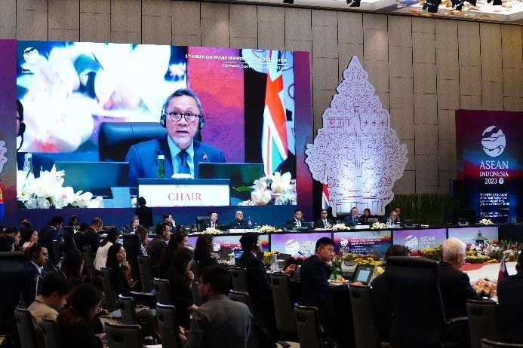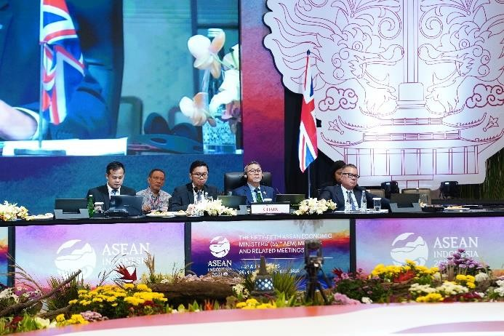
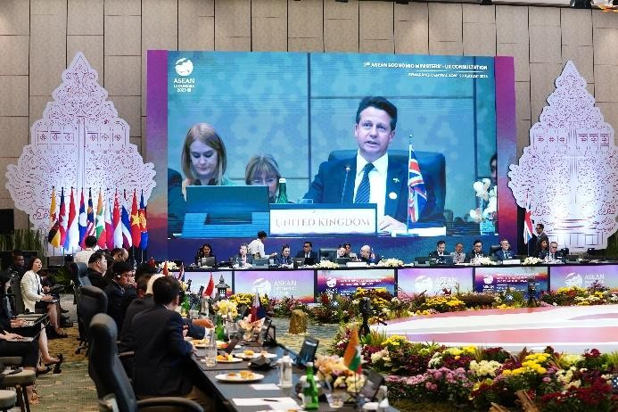
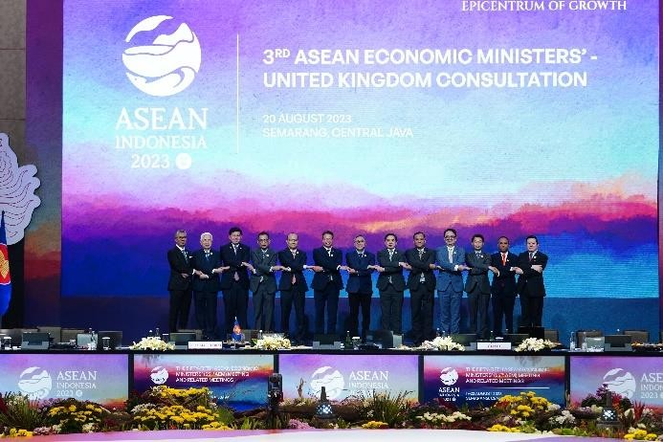

--end--

For further information please contact:  Ani Mulyati  Head of Public Relations Bureau Ministry of Trade  Email: pusathumas@kemendag.go.id | Dina Kurniasari  Director of ASEAN Negotiations  Directorate General of International Trade Negotiations Ministry of Trade  Email: dina.kurniasari@kemendag.go.id

